Xiaoting Lian

CISC 3140

LAB 9

This assignment for me is more like lab 5, similar to what we did. We want to find specific data from excel file or a database. the problem I was doing in the [Postgres Exercises](https://www.pgexercises.com/).

The question is “Find the upward recommendation chain for member ID 27: that is, the member who recommended them, and the member who recommended that member, and so on. Return member ID, first name, and surname. Order by descending member id.” The reason I picked this problem is because I’m not familiar working with recursive problem.

Why do I choose this database?

The exercise only give problem, the database is already picked. I have no choice.

with recursive recommenders(recommender) as (

select recommendedby from cd.members where memid = 27

union all

select mems.recommendedby

from recommenders recs

inner join cd.members mems

on mems.memid = recs.recommender

)

select recs.recommender, mems.firstname, mems.surname

from recommenders recs

inner join cd.members mems

on recs.recommender = mems.memid

order by memid desc

this is the correct code for this problem. And the result is

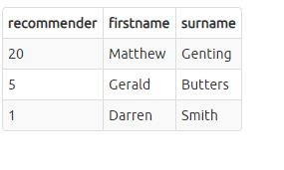

I didn’t get the answer, and I tried several times still got it wrong, it keeps giving me error.

ERROR: syntax error at or near "."

Position: 121

Or

ERROR: relation "members" does not exist

Position: 178

Something like these in different position. Since this web doesn’t have which line has error, it’s kind difficult for me to find where is the error, I end up have to take look the answer.

Since im bad with recursive, I will do more these type of questions.